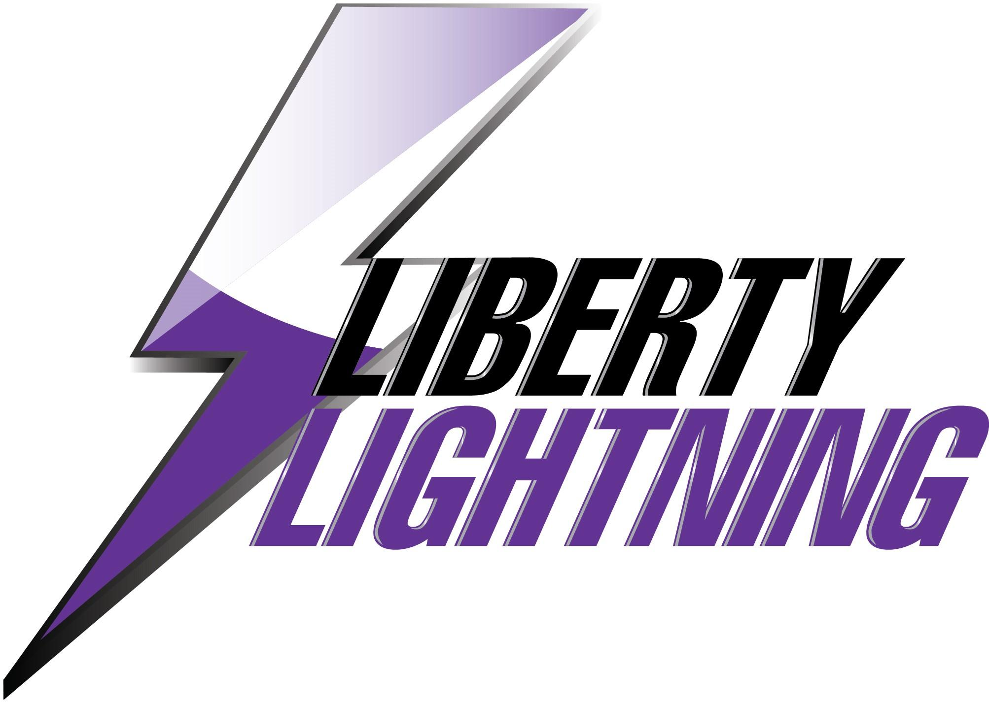

LIBERTY LIGHTNING GIRLS SOCCER 2026

VARSITY ROSTER

No. | NAME |  | Position |  | Year
0 | Ava Tague |  | GK |  | 12
1 | Mia Ungs |  | Defense |  | 11
2 | Rechal Darpe |  | Defense |  | 9
3 | Izzy Allen |  | Defense |  | 11
4 | Acasia Lukalaba |  | For/Mid |  | 10
5 | Aubrey Hunter |  | Forward |  | 10
6 | Shay Sundblad |  | Def/Mid |  | 12
7 | Allie Hunter |  | Defense |  | 11
8 | Callie Stanley |  | For/Mid |  | 12
9 | Ema Lucio |  | Mid/Def |  | 11
10 | Kali Browning |  | Defense |  | 12
11 | Reed Borgwardt |  | Mid/For |  | 9
15 | Lucia Michalec |  | Mid/For |  | 10
16 | Kamiya Browning |  | Forward |  | 10
17 | Eleanor Johnson |  | Mid/Def |  | 9
18 | Kacie Burke |  | Defense |  | 9
19 | Delilah Espinoza-Kroona |  | Mid/Def |  | 10
20 | Morgan Bennett |  | Forward |  | 11
22 | Parker Rouse |  | Def/Mid |  | 11

Varsity Head Coach: Frank Fiordellisi

Varsity Asst. Coaches: Ryan Steward, Lizzy Ward, Abigail Mayo, Sami Brookens, Ava Warkentin,

Managers: Rachel Sanders, Kaelyn Clark, Veda Smith, Avolynn Hays

