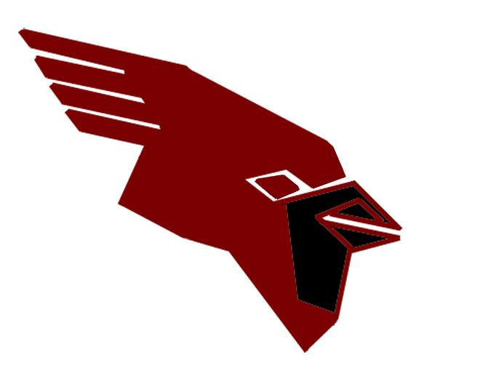
Middleton Girls Varsity Soccer 2026
Varsity Coach: Mary Duffy
Asst. Varsity Coaches: Kevin Pauls & Olivia Riggs
Volunteer Asst. Varsity Coaches: Kate Megna and Dalina Jonuzi
JV Coaches: Isaias Colegial, Ben Mertens, Jami Moris, Kelly Etter,, Lara Ferrari
Managers: Lola Jonuzi
# | First Name | Last Name | Position | Gr.
0 | Kylie | Carbon | GK | 12
1 | Finley | Pawelka | GK | 12
2 | Beatrice | Norman | DEF | 12
3 | Elspeth | Avery | MID/DEF | 11
4 | Tatum | Flaten | MID/DEF | 12
5 | Zoe | Sharaf | MID/FWD | 12
6 | Isabel | Frantz | MID/FWD | 12
7 | Brooke | Lister | MID/FWD | 11
8 | Amy | Medsker | MID/FWD | 11
9 | Madalyn | Kelm | MID | 12
10 | Solenne | Rohlwing | MID/FWD | 11
11 | Sydney | Hewuse | MID/FWD | 10
12 | Ashly | Mireles Albarran | FWD | 12
13 | Constance | Watson | MID/FWD | 10
14 | Katelyn | Zutter | MID/FWD | 11
15 | Norah | Feinberg | DEF | 12
16 | Sophie | Shi | DEF | 12
17 | Ziva | Gibson | DEF | 11
18 | Teagan | Kadow | MID/FWD | 11
19 | Annu | Mundas | MID/FWD | 9
20 | Emily | Hagen | MID | 12
21 | Amaya | Rao | MID | 9
22 | Stella | Schroeder | DEF | 11
23 | Leighton | Weber | FWD | 9

